Computer Vision HW2

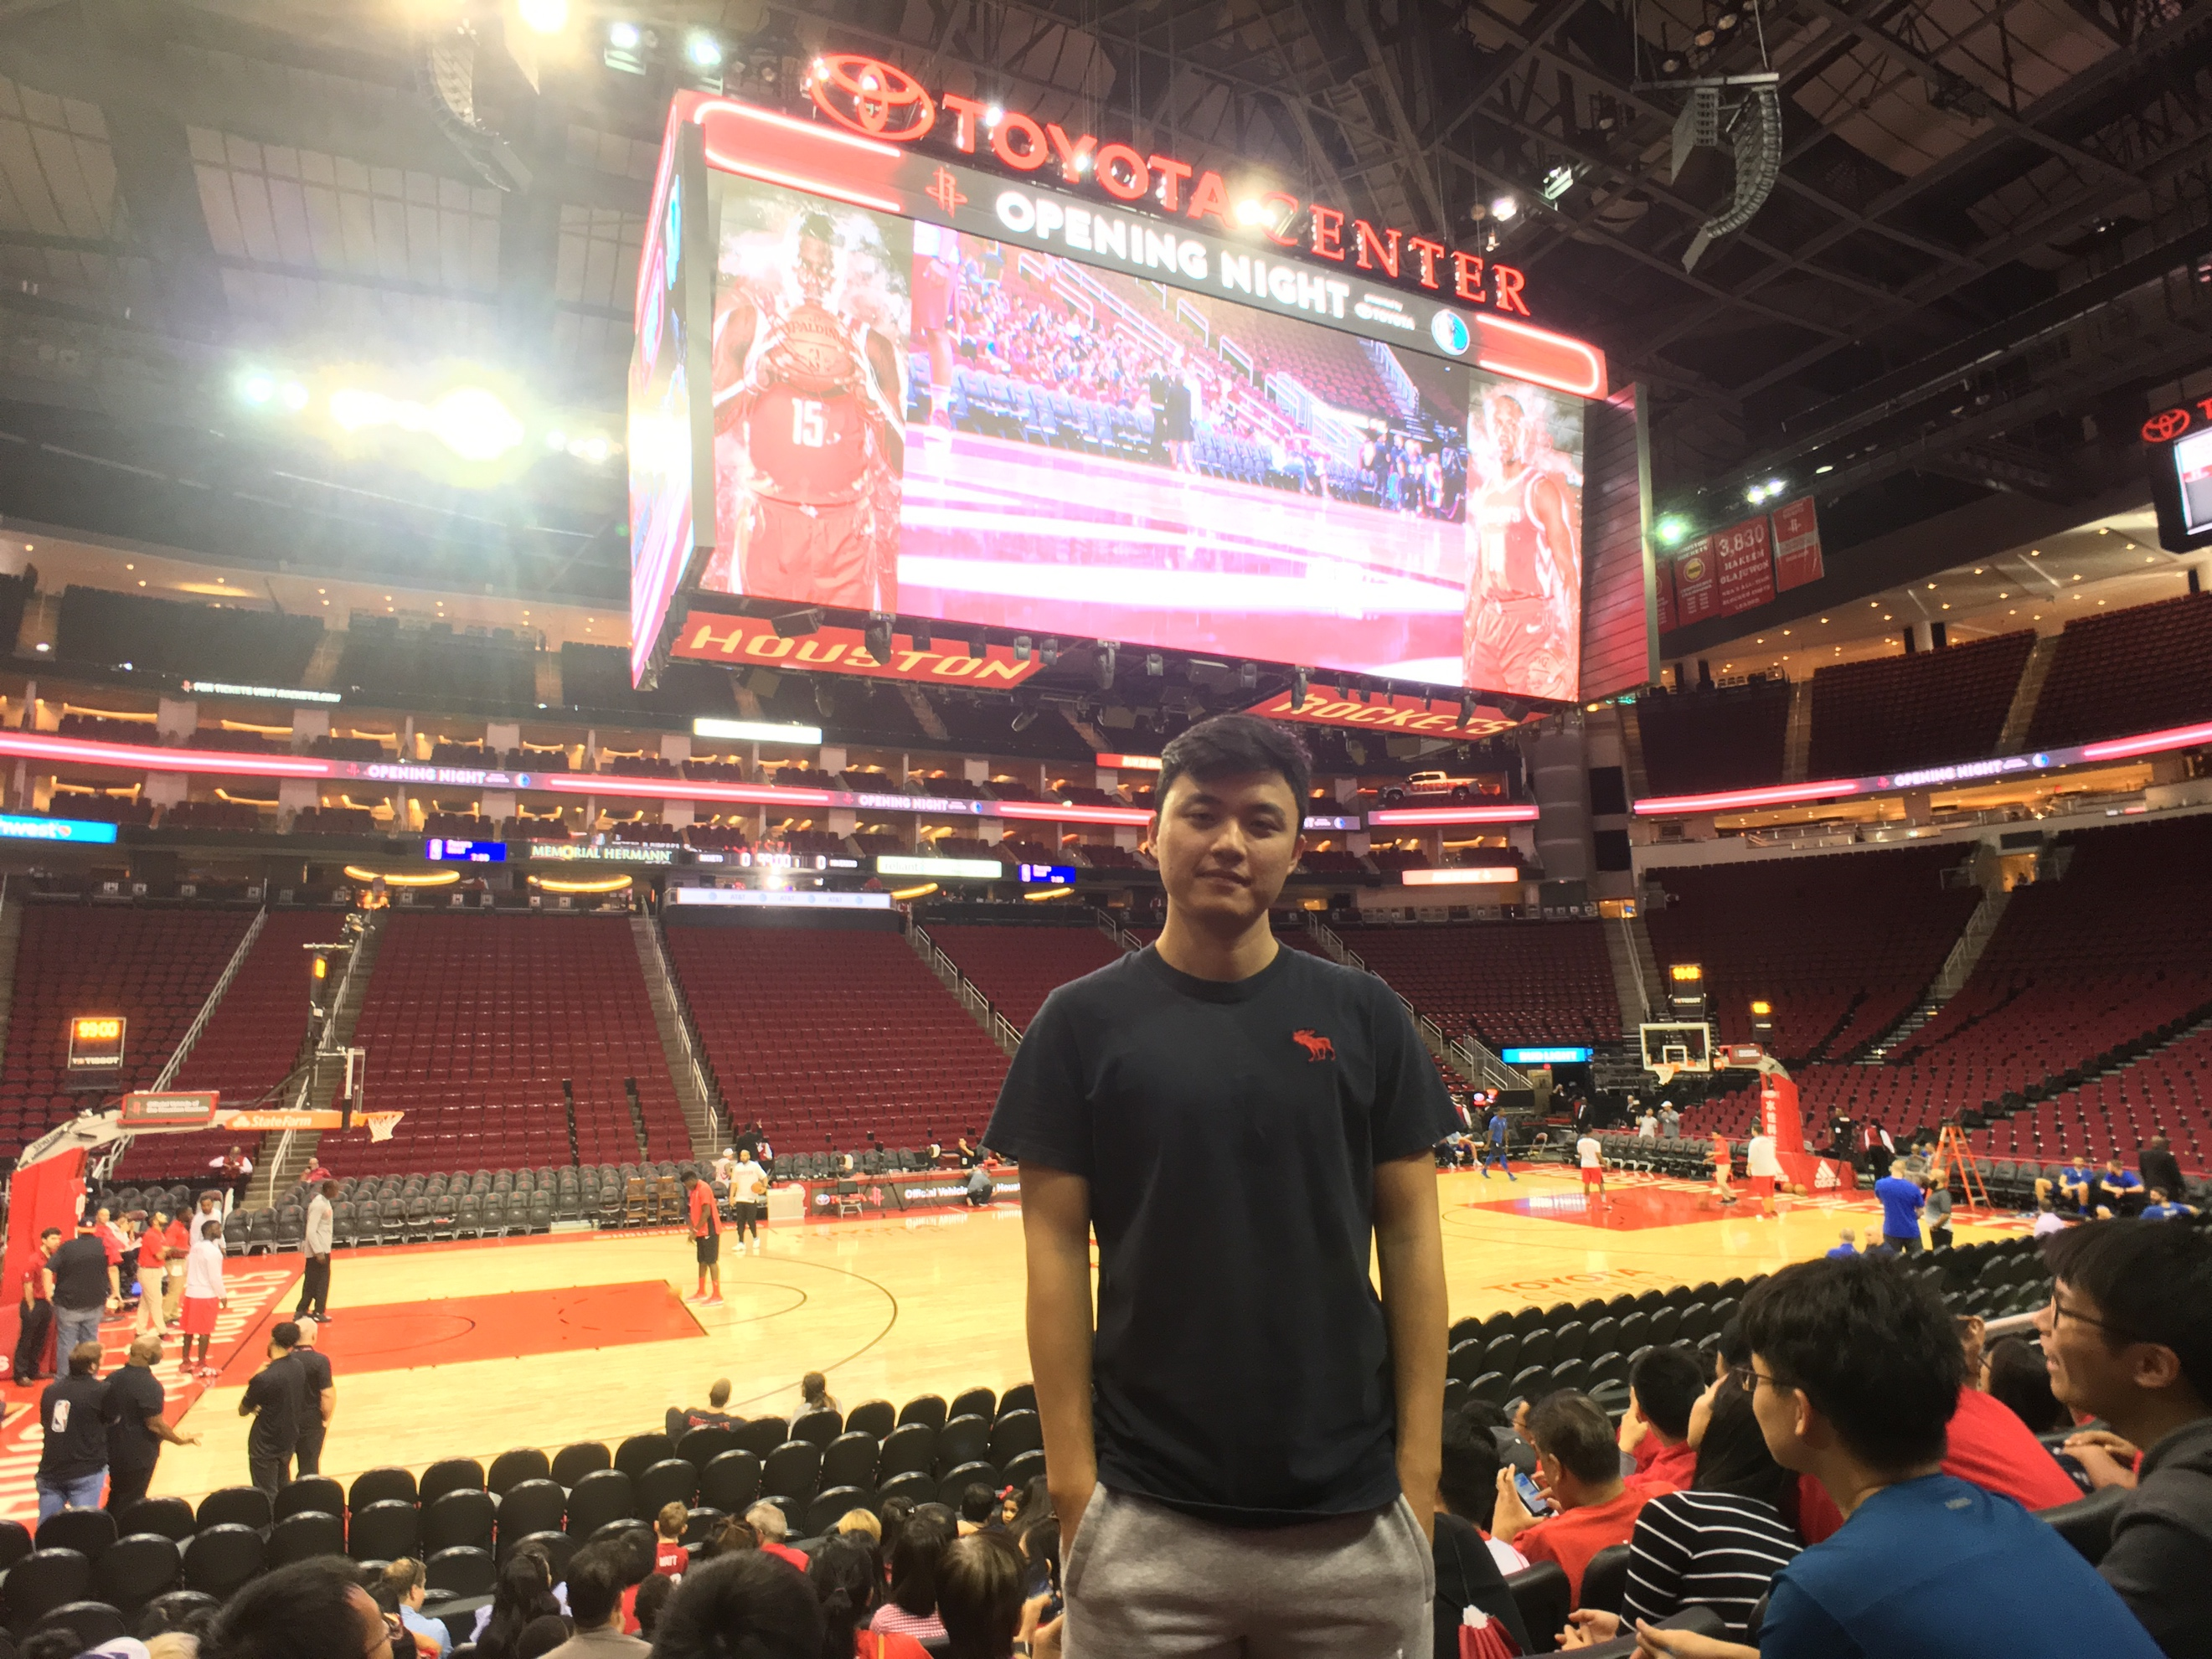Chien-Cheng Lai

ChBE

1. Canny Edge Detection

The Canny Edge Detection, developed by John F. Canny in 1986, is a computational approach using a multi-stage algorithm to detect a whole range edge in images. It is very useful if we tempt to extract the image’s structural information which would tremendously increases the efficiency in image data process.

The major criteria of canny edge detection include three followings:

1. Low error rate: Meaning a good detection of only existent edges, minimizing the probability of both failing to mark real edge points and non-edge points marking.
2. Good localization: The distance between detected edge pixels and real edge pixels have to be close as possible.
3. Minimal response: Only one detector response per edge. The first criteria implicitly include this one but the mathematical method doesn’t capture this critiria so it need to be done explicitly.

In order to implement the canny edge detector algorithm, these steps below must be followed.

1. Filter out noise in the original image, usually with the Gaussian filter.
2. Find the intensity gradient of the image.
3. Find the edge direction.
4. Apply the non-maximum suppression
5. Use hysteresis to eliminate the streaks.
6. Canny Edge Detection

* Noise Reduction

I filter out the noise of the image by given filter after padding the image. As the result,

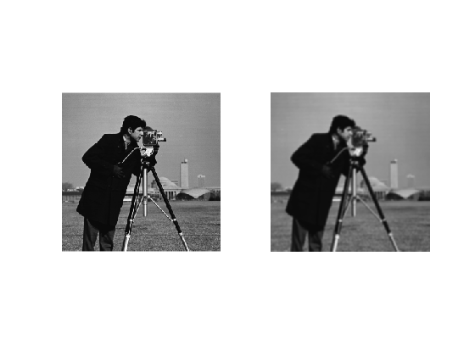

* Gradient Magnitude and Angle

Find the gradient intensity gradient and then determine edge direction in four degrees, 0, 45, 90 and 135. The gradient of image is showed below.

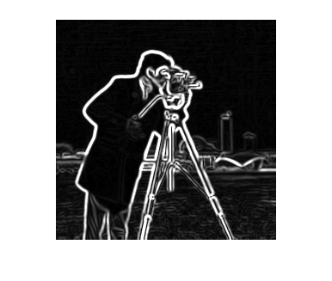

* Non-Maximum Suppression

Find the edge with only one pixel. As the result showed below.

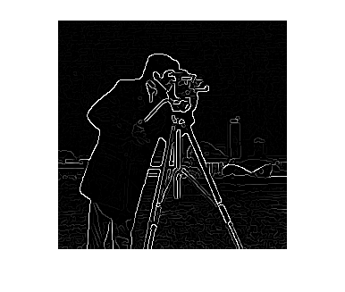

* Hysteresis Thresholding

Remove the unwanted edges by hysteresis thresholding with high threshold equals 187 and low threshold equals 110. As the result showed below.

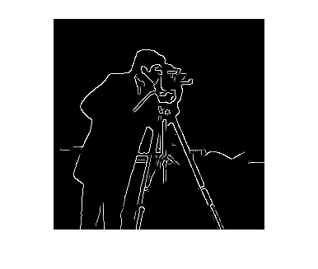

1. Hybrid Images

Hybrid images is a computational approach to produce a images with two different interpretations with a function of distance. It is based on human visual system in multiscale process input.

Generally, we combine two images with different spatial scales, one with the low spatial scale obtained by low pass filter, the other with high spatial scale obtained by high pass filter.

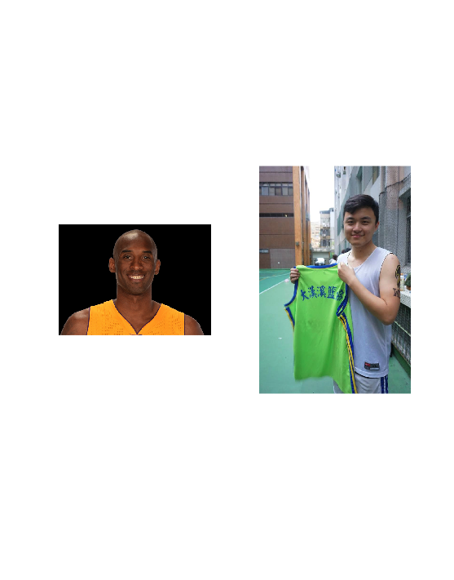

I combine these two images with hybrid images technology. The picture on the left is filtered by high pass filter and one on the right is filtered by low pass filter.

As the result,

